CSY4010 (Computing Dissertations) Interim Report on

**Sign Language Interpreter**

**BY**

Nima Dorje Lama

UN ID: 21422145

BSc Computing (Software Engineering)

Supervisor: Roshan Koju

NAMI College

University of Northampton

Jorpati, Kathamandu, Nepal

16th June 2023

**Table of Contents**

* 1. Project Introduction
     1. Project background
     2. Project Aims and Objectives
  2. Literature review
  3. Requirement Analysis
     1. Comparable System
     2. Elicitation Activities
        1. Interview plans
        2. Interview findings
        3. Interview 1– client name
        4. Interview 2-client name
  4. Requirement Specification
     1. Problem Domain Research
     2. Information Gathering
     3. Identification of alternative solution from existing systems
     4. Proposed solution strategy
     5. Functional Requirements
  5. Research Methodology and implementation
     1. Data collection
     2. Data processing
     3. Model Training
     4. Model Evaluation
     5. Integration
     6. Deployment
     7. Maintenance
  6. Testing and Evaluations
  7. System Design and Analysis
     1. Entity Relationship diagram
     2. Database schema and its Relationship.
     3. Use Case Diagram
  8. Resources Requirements
  9. References
  10. Appendix
      1. Project Gantt Chart

## Project Introduction

According to recent records there are around 700,000 to 900,000 deaf people in the world. Sign language is the gestural language that is used by deaf people or people with hearing disability. Sign language uses hand gestures and expressions to communicate with each other. The sign language interpreter system aims to help users to close communication barriers faced by deaf and other people. This project uses deep learning methods, specifically Python’s Keras library to convert sign language hand gestures into textual form in real-time so that others can know what they are saying. It closes the communication barriers between deaf and non-deaf people.

In recent years technology has been so huge in industry and day to day work. There is also advancement in deep learning and computer vision which helps for the automation of sing language interpreter systems. Although it needs some improvement in handling various sign languages. To improve this problem the project uses Django framework as it helps to create a beautiful design and easy to understand system and its interface which can be used by all.

This system’s main objective is to include give accurate sign language interpreter system which is capable of converting sign language to textual form. It breaks down the hand gesture and helps to recognize the gesture and gives text as an output which helps in breaking barrier in communication. By using the power of deep neural networks, data processing techniques and the web base platform this system will help everyone try to learn or convert sign language to text form. This system also aims to help sign language users to participate in various domains such as education, healthcare, employment, and social interactions.

The main goal of this system is to enable effective communication between both deaf and non-deaf people. Exploiting the capabilities of Python, Keras, Deep learning, Open CV and Django, this system provides seamless communication. It will help to provide equal opportunities for all.

There are also many challenges for this system. Since it is an AI based system and cannot always be accurate which may lead to misunderstanding and frustration. Although it will have a user-friendly system for those who know a bit of technology but for those who don’t have anything about technology it will be hard and create a barrier for some deaf people.

### Project background

The idea of development of this system comes from the recognition of communication challenges faced by the people deaf people and non-deaf people. This kind of language is very complex to understand as it uses complex visual gestures which create a barrier for users who don’t understand sign language. With the help of deep learning techniques specifically Python’ keras library, this system helps to convert sign language gestures into text form in real time.

There is always a need for a robust solution that can handle sign language and operate in real-time. Previously, much research has been done but this kind of system has never been published but if published it is paid and its price is very high. By using the power of deep learning methods, this system helps deaf communities to participate fully in many industries which help them to come out in the society freely without any hesitation. To make this possible, the project uses deep neural networks, efficient data processing techniques and it uses Django framework for a user-friendly web-based interface.

For a sign language learner this system will provide sign language tutorial videos and a converter that can convert text to sign language form with the help of image and videos which make this system helpful for both sign language user and non-sign language user. This will enable easy adaptation and integration of the system into various contexts and help each and every individual.

In the present time, there is a website where users can login, sign up and log out from the system. User gets a user-friendly website, and this website provides information about sign language. This website can convert text into sign language with the help of images till date. The data set of American Sign language is also collected and augmented.

In future it will have a system where a person needs to login to system and get access to web dashboard with all features. It will capture images and video to convert sign language to textual form. It will detect all the English characters and some greetings.

### Project Aims and Objectives

#### Aims:

* To develop a sign language interpreter system for effective communication between sign language users and non-sign language users.
* Improve participation in various industries, including education, employment, healthcare, and social interactions.
* Improve user experience through the integration of a user-friendly and easy web-based interface using the Django framework.
* Use deep learning techniques, Python’s keras to achieve accurate conversion of sign language gesture into textual representations.
* Help to preserve sign language as it is at risk of being lost. It will allow people to use the system in a variety of settings and in remote areas.

#### Objectives:

* Develop a real-time sign language interpreter system that can detect and interpret sign language into text in real time.
* Improve the accuracy and expressiveness of the interpreter, capturing hand shape gestures and facial expressions.
* Design a user-friendly interface that is visually appealing and facilitates easy interaction between the system and users, including both kinds of user.
* Integrating a video tutorial system for non-sign language users to learn sign language.
* Empowering individuals with hearing difficulties by enhancing their independence in communication through a reliable and accurate sign language interpreter system.
* To make the system more affordable.

## Literature review

<https://ieeexplore.ieee.org/document/10084015>

This paper proposes a sign language interpreter system that uses deep learning methods to translate sign language into a textual form. The system is composed of two main components a sign language recognition component and a text generation component. The sign language recognition component uses a deep convolutional neural network to recognize the signs and gestures in a video stream. The text generation component uses a recurrent neural network to generate the text which is the result of gestures.

The authors evaluated the system on a dataset of sign language videos. The result shows that the system was able to achieve and accuracy of 90% on the sign language recognition task and an accuracy of 85% on the text generation task. The authors also found that the system was able to handle a variety of sign language gestures and facial expressions. The authors concluded that the system’s future work is to improve the accuracy of system.

I found that the system is also able to handle different lighting conditions and background clutter. This is important because it means that the system can be used in a variety of settings, such as classrooms, conference rooms, and public spaces. The system is easy to use. The user simply needs to wear a video camera and speak into a microphone. Then the system recognizes the gesture and generates the textual representation of the sign as output. This makes the system friendly for a wide range of users, including deaf and hard-of-hearing people, as well as people who are willing to learn sign language. I believe that the system proposed by Zhang et al is a promising approach for developing sign language interpreter system. The system is accurate, robust, and user-friendly. This system has potential to improve the lives of deaf and hard-of-hearing people by making it easier for them to communicate with others.

<https://ieeexplore.ieee.org/stamp/stamp.jsp?tp=&arnumber=9456176>

The paper proposes a video-based sign language translation system using machine learning algorithms. The system is designed to help deaf and mute people communicate with each other, they system works by first detecting the signer in a video stream in a video stream then it segments the video into frames and recognizes the sign in each frame. Finally, is translated and recognized into text.

The author found that their system was able to achieve an accuracy of 92.4% on a dataset of ASL signs. They also found that the system was able to translate signs in real time. This system uses two different learning algorithms RNN and CNN.

I get to learn about the different machine learning algorithms. The system could be improved by using a larger dataset for sign language videos. It could make more robust to variations in lighting and background conditions. The system could be more accessible to people with different levels of hearing loss.

<https://www.researchgate.net/publication/361079073_Deepsign_Sign_Language_Detection_and_Recognition_Using_Deep_Learning>

This paper proposes a deep learning-based system for recognizing sign language actions. The system is composed of two main modules: a feature extraction module and a classification module. The feature extraction module uses a CNN network to classify the extracted features into different sign language actions.

The authors conducted an experiment on two public datasets of sign language videos: ASL fingerspelling Alphabet Dataset and ASL alphabet dataset. The result od the experiment showed that the proposed system achieved a recognition accuracy of 98.3% on the ASL fingerspelling alphabet dataset and 97.7% on the ASL alphabet Dataset.

The authors could have explored using other deep learning architectures for the feature extraction and classification modules. For example, they could have used a 3D CNN or a RNN instead of a CNN or LSTM. The author could have explored using the system to recognize sign language gestures in real-time. This system would be more practical for use in applications such as video conferencing and sign language interpretation.

<https://ieeexplore.ieee.org/stamp/stamp.jsp?tp=&arnumber=9971953>

This paper is about the improvement of accuracy in sign language using transfer learning. This model is trained on large dataset of images of hand gestures. This system uses a large dataset and gives a text transcription. This system can help to improve the accuracy of the model, as it is trained twice, and it will have learned some of the features that are important for recognizing hand gestures.

The author of this paper evaluated their approach on a dataset of 87,000 images of hand gesture. They found that their model was trained using transfer learning and achieved an accuracy of 98.7%. This is a significant improvement in the accuracy of a model that was not trained using transfer learning (94%). Their model was able to achieve real-time performance and can convert sign language to text in fractions.

I found out that transfer learning is a powerful technique that can be used to improve the accuracy of machine learning models. Real-time sign language to text conversion is a challenging task but it is possible to achieve high accuracy using transfer learning. The development of a commercial product that could help people who are deaf to communicate more effectively would be a valuable contribution to society.

## Requirement Analysis

### Comparable System

American Sign Language Translator

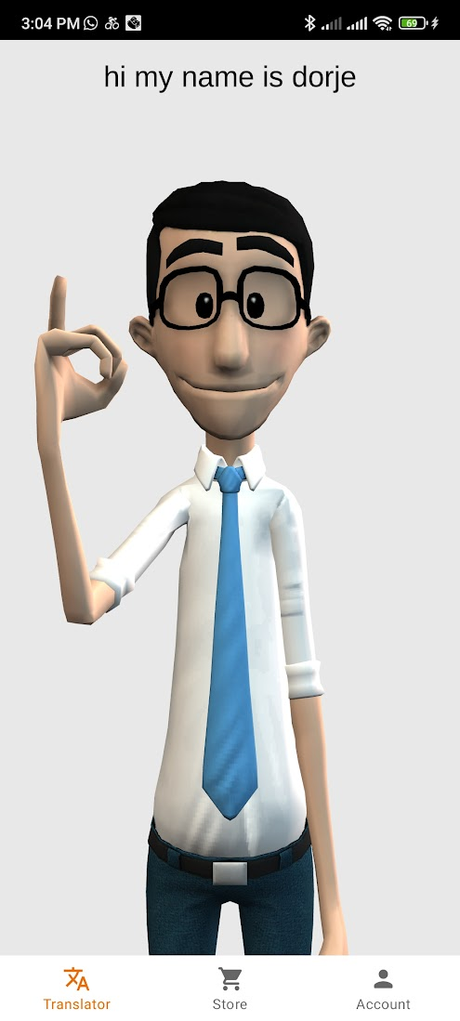

This system is available in the play store. This system takes text as an input and the character in the image above gives a video demonstration with sign language gesture.

The advantages of this system are:

* Convenient and accessible: ASL apps can be used anywhere, at any time. This makes them a convenient and accessible way to learn ASL especially for people who live in areas with limited access to sign language classes or interpreters.
* Interactive and engaging: ASL apps often use a variety of interactive and engaging features to help users learn ASL, such as game, Quizzes, and flashcards. This can make learning ASL more fun and motivating.
* Personalized Learning: Many ASL apps allow users to customize their learning experiences. This means that user can focus on the areas of ASL that they are most interested in or that they need to most practice with.

Disadvantage:

* Cost: ASL apps can be expensive, especially if you want to use a premium version with more features.
* Accuracy: The accuracy of ASL apps can very depending on the app. Some apps are more accurate than others, so it is important to do your research before choosing and app.
* Lack of human interaction: ASL apps cannot replace human interaction. If you are serious about learning ASL, it is important to also take sign language classes or work with a sign language interpreter.

Web capable tools:

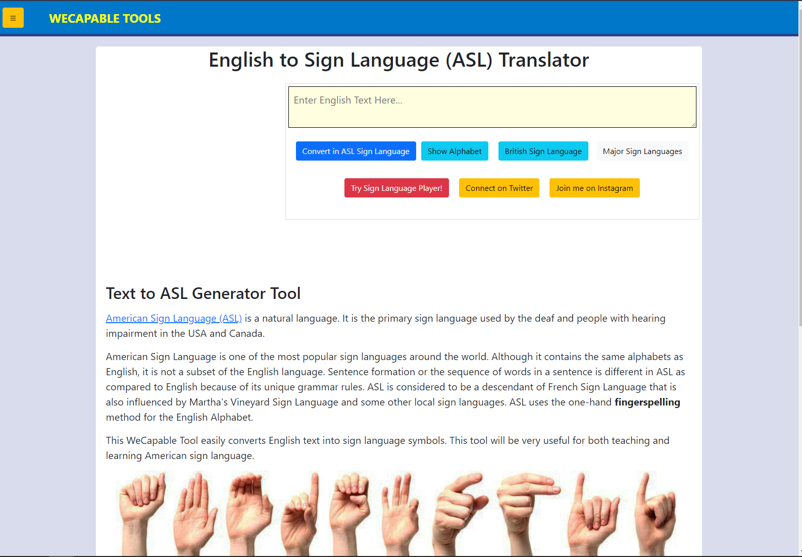

You can find this system in the browser as it is only web base. This system can convert text into image sign language form. If you search for a word, it will give you a word in sign language in image form.

Advantage:

* Easy to user: Since it only converts text to image sign language it is easy for user to user.
* Help in learning: The one who is willing to learn sign language system, you need to search it and it will provide image with the sign language in it which help user to learn.

Disadvantage:

* Needs Internet: Since it is web base application you device needs to be connected to internet which is hard for remote area.
* Convert to image: It only convert text to image for but it does not do real-time conversion.

### Elicitation Activities

To develop a successful system, it is important to gather information from the target audience. This can be done through interviews, observations, user surveys and usability testing. By conducting these elicitation activities, the project team can get a better understanding of deaf people.

#### Interview plans

To interview or get knowledge about the user need. We can ask questions that are similar to it:

* What are the challenges you face when communicating with sign language?
* How do you think a sign language interpreter system would help you to communicate more effectively?
* What features would you like to see in this system?
* What are your concerns about the use of this system?

#### Interview findings

* Deaf people face several challenges when communicating in sign language, especially in noisy environments, difficulty interpreting signs from different signers and difficulty following fast-paced conversation.
* Interpreters can be expensive and difficult to find in rural areas.
* Interpreters cannot always be accurate as different regions have different forms.
* Most people do not know sign language that creates a barrier in a lot of places like health care, education, and all.

## Requirement Specification

Requirement specification refers to the detailed documentation that outlines the specific requirements and expectations for the content, structure, and format of report. The main reason behind the requirement specification is to ensure that the system that is developed meets the needs of the user and stakeholders. It helps to ensure the development of the system is efficient and on time.

### Problem Domain Research

Problem domain research is focused on understanding the problem that a system is trying to solve which includes understanding the users of the system and needs and problems of users taking feedback from the user. It is very important for a system because it will help to develop the system that is solving the problem that is intended to solve.

Without this system the problem that is faced the peoples are mentioned and explained below:

* Communication Barrier between deaf and hard of hearing:

The main problem in this domain is the communication barrier that is between deaf people and non-deaf people. Since many people don’t know sign language and deaf people feel uneasy to communicate with others which leads them to not socialize much. This barrier also hampers many industries like education, employment, and social growth.

* Limited Availability and Reliability of Interpreters:

The main challenge is to hire a sign language interpreter that can interpret your sign language all the time. There is often a shortage of qualified interpreters, especially in remote areas or with specific language variations. Since humans cannot always be accurate and might interpret with errors and generally slow as it must go through 2 people and time consuming.

* Variation in Sign languages:

In this world there are many languages according to their region, culture, and all. If non-sign language user has these many languages, then it is obvious that the sign language also varies across different regions and cultures which creates a challenge system to adapt to every sign language variation. The system must provide the information about the language that is converted by the system which in this case is American Sign Language (ASL).

* Usability and User Experience:

Developing a user-friendly interface that is easy to understand and good for both users. Since it must be seamless user experience, ensuring ease of interaction and promoting efficient communication.

* Learning Sign Language:

There are very small resources for learning sign language as it varies from region to region it is very hard to find a professional interpreter that can teach someone which leads to a problem of learning it.

By evaluating problem domain research helps to overcome challenges and complexities involved in developing a sign language interpreter system. It helps to get accurate and expressive interpretation, integration of user-friendly environment.

### Information Gathering

Before making a system, gathering information is very important as it helps to understand the need of industry and needs of users. Some of the information gathering of this project is mentioned and explained below:

* Interview deaf people:

While observing deaf people communicating with each other in person there were lots of problems as the person beside sign language user it was hard for them to explain.

* Survey deaf people:

Survey deaf people to gather their feedback on the current state of sign language interpreter systems and their needs for future systems.

* Interview deaf people or sign language interpreter:

Interviewing deaf or interpreters is the best way to understand their experiences with sign language and the challenges they face in communicating with others.

* Review existing research:

Review existing research on sign language interpreter systems to learn about the different approaches that have been done in the past and challenges that have been encountered.

* Build a prototype system:

Build a prototype system to test different approaches and get feedback from the people using sign language and who want to learn it.

Gathering this much information, you can have an idea what are the requirements and existing technologies that need to be in your system.

### Identification of alternative solution from existing systems

* Live sign language interpreters:

Live sign language interpreters are the gold standard for sign language interpretation. This system has many trained professionals who can translate sign language into speech or text in real life. It is very expensive, and it is not available in all settings.

* Video relay services:

Video relay deaf people allows people to communicate with heating people over video chat. It relies on the conversation between the deaf person and the heating person. VRS is a more affordable option but can be less accurate.

* Automatic Speech Recognition (ASR) Systems:

This system converts spoken language into written text. This system can be used in larger systems to transcribe language inputs and it processes it and gives interpreted output.

* Gesture recognition Systems:

This system can interpret hand movements, gestures, and body language. This system users use computer vision and capture the video and analyze which translate into sign language representation.

It is essential to evaluate other system strength, limitations, and suitability for the specific requirements of the sign language system project. Understanding the existing systems one can identify the technologies, methods and help to enhance the system accordingly.

### Proposed solution strategy

The proposed solution strategy of this project is explained below:

* Real time interpretation:

System must prioritize real time interpretation capabilities to have seamless communication between the sign language user and non-sign language user. It must implement efficient algorithms and give accurate output.

* User-Friendly Interface:

Develop user friendly interface that is easy to understand and easy to use for both users. System prioritizes clear visual and engaging UI so that users find it user-friendly.

* Natural Language Processing and Computer Vision:

System should utilize Natural Language Processing (NLP) techniques and computer vision algorithms to analyze sign language input and interpret them into text or voice form as output. This system involves developing models and algorithms that can capture sign language like handshapes, gestures, facial expressions, and body movements.

* Continuous Improvement and User Feedback:

The system must improve according to the needs of users. To know what should be improved, the monitoring of user feedback should be taken. System can gather user feedback using user testing sessions and utilizing data to identify for improvement and address user needs.

* Iterative Development Approach:

The project follows some development approaches, such as Agile and extreme programming to enable flexibility and continuous improvement. It will allow the system to add new features, fix bugs and take user suggestions throughout the development lifecycle.

* Ethical considerations and Cultural Sensitivity:

System must embed ethical considerations and cultural sensitivity into the design and development process. System must ensure that the system respects the cultural values of sign language communities and promotes its data protection and privacy.

By adopting these many solutions strategies, this system aims to create a robust and user-centric software solution that bridges the communication gap between sign language users and individuals who do not understand it. The strategy helps in understanding advanced technologies, adaptability, user-friendliness, continuous improvement, and collaboration to ensure an effective user experience.

### Functional Requirements

Some of the functional requirements for the sign language interpreter system are:

* Real-time Interpretation:

The system should be capable of providing real-time interpretation of sign language to natural text language during the conversations. It should be accurate also.

* Accurate Sign language Representation:

This system should accurately represent the sign language expression, including handshapes gestures, facial expression, and body movement to give accurate output and change sign language to text form in accurate textual form.

* Gesture Recognition:

This system utilizes computer vision techniques to recognize hand gestures, movements, body language to interpret into a textual form with higher accuracy.

* User-friendly Interface:

The system must have a user-friendly interface that facilitates easy interaction between the system and users. It should have clear visuals, easy controls and have support assistive technologies for both sign language users and non-sign language users.

* Error Handling and Feedback:

Using robust error handling mechanisms to handle to recognize errors. The system should take clear feedback and suggestions from users in case of misinterpretations and is should be addressed.

* Data Security and Privacy:

The system implements some methods to ensure the security and privacy of user data, including secure storage of user information.

### Non-Functional Requirements:

* The system must be reliable and should not crash or freeze.
* The system should be scalable to handle many users.
* The system should be secure and affordable for both deaf people and hearing people.

## Research Methodology and implementation

This system will be based on Agile methodology. That means that the methodology is based on experience and observation, rather than on theoretical principles. Agile methodologies are also iterative and incremental, which means that the software is developed in small, incremental steps which helps developers to get feedback from users in early stages which leads the software to meet its need.

### Implementation

The typical way of implementing this methodology is done by a small, cross-functional team of developers. The team works together closely to develop the software, and they use a ton of agile practices. The practices are described below:

* Sprints: The software is developed in short sprints, typically two weeks in length.
* Acceptance criteria: The requirements for the software are defined in terms of acceptance criteria.
* Continuous integration: The system is integrated frequently, so that any problems can be identified and fixed early.
* Testing: The software is tested frequently, both manually and with automated tests.

Benefits of Agile Methodologies:

* Increase flexibility: Since agile methodology is flexible, the project team can change requirements.
* Reduce development time: Agile methodology uses iterative and incremental approach which lead to reduce the development time.
* Improved communication: Agile methodologies can help to improve communication by bringing the team together regularly to discuss the project.

Drawbacks of Agile Methodologies:

* Requires a skilled team: It requires a skilled team of developers who are familiar with agile practices.
* Can be difficult to manage: It can be difficult to manage because they are iterative and incremental.
* Not suitable for all projects: It is not suitable for all projects, such as projects where there is a high degree of uncertainty.

### Data collection

There are many data collection techniques some of which are explained below:

* Surveys: Surveys are a popular data collection method because they are relatively easy to administer and can be used to collect data from many people. Surveys can be conducted in person, over the phone, or online.
* Observation: Observation is a data collection method that involves watching and recording people's behavior. Observation can be used to collect data on a variety of behaviors, such as how people interact with each other, how they use products, or how they react to certain stimuli.
* Interviews: Interviews are a data collection method that involves asking people questions about their thoughts, feelings, and experiences. Interviews can be conducted in person, over the phone, or online.
* Focus groups: Focus groups are a data collection method that involves bringing a small group of people together to discuss a particular topic. Focus groups can be used to gather feedback on products, services, or ideas.
* Experiments: Experiments are a data collection method that involves manipulating one variable and observing the effects on another variable. Experiments are often used in scientific research to test hypotheses.

### Data processing

* Data collection: This is the process of gathering data from various sources. Data can be collected from surveys, interviews, experiments, and other sources.
* Data organization: This is the process of arranging data in a way that makes it easy to understand and analyze. Data can be organized in a variety of ways, such as by date, time, location, or other criteria.
* Data analysis: This is the process of examining data to identify patterns and trends. Data analysis can be used to make predictions, solve problems, and make decisions.
* Data visualization: This is the process of displaying data in a way that makes it easy to understand. Data visualization can be used to communicate the results of data analysis to others.

### Model Training

The first step is to choose a machine learning model that is appropriate for the task and the data must be fed into the model. The data is split into two sets: a training set and a test set. The training set is used to train the model and test set is used to evaluate the model’s performance. The model is trained by feeding the training data into the model and adjusting the model’s parameters until it learns to perform the desired task. The model’s performance is evaluated on the test set. The evaluation metrics can be used to determine the accuracy of a system. Once the model is trained and evaluated, it can be deployed to production. This means that the model can be used to make predication on new data sets.

### Model Evaluation

There are many ways to evaluate the model and some of it is:

* Accuracy: To check the accuracy of the system. If accuracy is lower than expected, then need to train the model correctly.
* Precision: It is the fraction of positive predictions that are positive.
* ROC curve: The ROC curve is a graphical representation of the model’s performance where it shows the accuracy, loss, and other aspects.
* AUC: They AUC is the area under the ROC curve.

### Integration

Integration is the process of combining two or more systems or applications or applications so that they can work together. You can eliminate the need to manually transfer data between systems. This can save time and money. Integration can be expensive and complex, and it is a challenging process. It can lead to security risks.